**"ENHANCING OPERATING SYSTEM ACCESSIBILITY FOR USERS WITH DISABILITIES: A REVIEW PAPER ON THE USABILITY OF VISUAL, AUDITORY, AND MOTOR IMPAIRMENT-AFFECTED INDIVIDUALS"**

Shruti Gupta

Department of Computer Science and Engineering, Lovely Professional University

[Shrutiguptaa1177@gmail.com](mailto:Shrutiguptaa1177@gmail.com)

Harshita Pathania

Department of Computer Science and Engineering, Lovely Professional University

[harshita.pathania03@gmail.com](mailto:harshita.pathania03@gmail.com)

Karishma Yadav

Department of Computer Science and Engineering, Lovely Professional University

[karishmayadav1517@gmail.com](mailto:karishmayadav1517@gmail.com)

**ABSTRACT**

This paper presents a comprehensive examination of the accessibility of operating systems for users with disabilities, focusing on individuals affected by visual, auditory, and motor impairments. In the context of growing reliance on digital technologies, ensuring equitable access to computing environments is critical. The study reviews the challenges faced by these users in interacting with operating systems and evaluates existing assistive technologies and solutions designed to address these challenges.

Through an analysis of major operating systems, including Windows, MacOS, and Linux, the paper evaluates current accessibility features, assessing their effectiveness and limitations. Research studies on the usability of these features for users with various types of impairments provide insights into their experiences and identify areas for improvement. Furthermore, the paper explores the common challenges across different disabilities, highlights technological barriers, and discusses potential solutions.

Case studies and best practices are presented to illustrate successful strategies in enhancing operating system accessibility. Recommendations for future improvements include the development of more inclusive features and better integration of assistive technologies. The paper concludes with a discussion on the social and policy implications of accessibility, and envisions a future where operating systems provide seamless, intuitive, and inclusive experiences for all users, regardless of their abilities.

**1. INTRODUCTION**

The digital world offers vast opportunities but navigating it can be difficult for individuals with disabilities. Operating system accessibility refers to the design principles that ensure user interfaces are usable by a diverse range of people, regardless of their abilities. This aligns perfectly with the concept of Universal Design for All (UDAL).

However, the current state of OS accessibility remains an evolving landscape. While these features have undoubtedly improved user experiences for many, challenges still persist. Research suggests compatibility issues between screen readers and certain applications (Szopa, 2021). Additionally, users with motor impairments may face difficulties navigating complex menus without proper keyboard shortcuts (Lazzaro, 1995). The question arises: How effective are existing accessibility features in truly supporting the needs of users with disabilities?

This review paper delves into this very question. We focus on three primary user groups: those with visual impairments, auditory impairments, and motor impairments. Our aim is to critically examine the current state of OS accessibility for these individuals.

**1.1 Importance of Accessibility for Users with Disabilities**

The World Health Organization (WHO) estimates that over 1 billion people globally live with some form of disability. Accessible operating systems play a crucial role in ensuring equal opportunities and independence for individuals with disabilities. By incorporating accessible design principles, operating systems empower users in various aspects of their lives, including education, communication, entertainment, and financial transactions (Gregor et al., 2005).

*Access to Education and Employment:* Accessible operating systems enable users with disabilities to access education and employment opportunities through digital platforms. They can utilize computers for online learning, job searching, and professional development, contributing to their personal growth and economic independence (Rivas-Costa et al., 2014).

*Effective Communication:* Accessible operating systems facilitate effective communication through email, social media, and other online services. Users can stay connected with others, share information, and participate in social activities without barriers posed by inaccessible technology (Borg et al., 2015).

*Engagement in Entertainment and Recreation:* Operating systems with robust accessibility features allow individuals with disabilities to engage in entertainment and recreational activities. They can enjoy watching videos, playing games, and accessing multimedia content independently, enhancing their quality of life (Malone et al., 2023).

*Secure Participation in E-commerce and Online Banking:* Accessible operating systems ensure secure participation in e-commerce and online banking for users with disabilities. By removing accessibility barriers, individuals can manage their finances, make purchases, and engage in online transactions confidently and safely (Rogers et al.,1999).

Accessible operating systems are essential for fostering inclusivity, promoting independence, and empowering individuals with disabilities to fully engage in the digital age, benefiting both users with disabilities and society as a whole.

**1.2 Scope and Objectives of the Review**

The objective is to examine recent findings, patterns, and advancements in improving operating system accessibility for people with disabilities. The main goals consist of:

*Identifying Accessibility Challenges:* Talking about typical obstacles that people with disabilities encounter when using digital devices and operating systems (Ellcessor, 2015).

*Examining Accessibility Features:* Examining the accessibility features that are now in place and those that are being developed for widely used operating systems like Windows, macOS, Linux, iOS, and Android (Burgstahler et al., 2004).

*Analyzing User Experience:* To determine how well accessibility features address a range of demands and enhance usability, user experiences and feedback are examined (Hussain et al., 2018).

*Contributing to Inclusive OS Development:* By critically examining existing research findings and user experience studies related to OS accessibility for individuals with disabilities, this review aims to contribute to the development of more inclusive operating systems. These future systems should cater to the diverse needs of all users, fostering a more equitable digital experience (Szopa, 2021).

This review delves deeper into the existing landscape of OS accessibility, exploring the challenges faced by users with disabilities and identifying potential areas for improvement. By critically examining current research, this review aims to pave the way for the development of more inclusive and user-friendly operating systems for everyone.

**2. UNDERSTANDING DISABILITIES AND THEIR IMPACTS ON COMPUTER USAGE**

**2.1 Visual Impairments**

A variety of conditions can impair a person's vision, collectively referred to as visual impairments. This section examines the different kinds and intensities of visual impairments, the difficulties in utilizing operating systems, and the assistive technologies that help visually impaired people cross the digital divide.

*2.1.1 Types and Severity of Visual Impairments*

According to the World Health Organization (WHO), blindness is defined as having a field of vision that is less than 10 degrees or having visual acuity in the better eye with best correction of less than 3/60, or 10% of normal. Low vision is a term used to describe a partial loss of vision that has a major impact on daily activities and cannot be fully corrected with glasses or contact lenses (Vashist et al., 2022).

*Blindness*: Age-related macular degeneration (AMD), glaucoma, cataracts, diabetic retinopathy, and genetic disorders are among a few causes of blindness.  
   
*Low Vision*: A variety of visual acuities and field of vision restrictions fall under this category. Loss of peripheral vision impairs movement and the ability to detect obstacles, while loss of central vision makes activities like reading challenging.  
  
*Color blindness*: People who are color blind typically have trouble telling one color from another, with red-green and blue-yellow being the most prevalent combinations.   
  
*Age-Related Macular Degeneration (AMD)*: A degenerative condition that gradually damages the macula, the area of the retina in the center that provides clear central vision. AMD can cause mild blurred vision in its early stages, central vision loss in its intermediate stage, and severe vision loss in its late stages (Guymer et al., 2020).

**Table 1. Vision Impairment: Types and Severity (Vashist et al., 2022)**

|  |  |
| --- | --- |
| **Category** | **Definition (based on present visual acuity of better eye with available correction)** |
| Blindness | <3/60 |
| Severe visual impairment | <6/60-3/60 |
| Moderate visual impairment | <6/18-6/60 |
| Mild visual impairment | <6/12-6/18 |
| Moderate-severe visual impairment | <6/18-3/60 |
| Visual impairment | <6/12 |
| Pinhole Blind | Best corrected vision <3/60 in better eye |
| Functional low vision | A person with impairment of visual functioning even after treatment and/or standard refractive correction, and a visual acuity of less than 6/18 to light perception, or a visual field of less than 10 degree from the point of fixation, but who uses, or is potentially able to use, vision for planning and/or execution of a task. |

*2.1.2 Challenges Faced in Operating System Usage*

There are a number of difficulties that visually impaired people encounter when utilizing computer and mobile operating systems.

*Having trouble seeing visual elements*: It can be challenging to read small text, icons with little detail, and interfaces with weak color contrast (Bilal Salih et al., 2022).  
  
*Absence of ability to understand spatial relationships*: It can be difficult to comprehend window layouts, menu hierarchies, and visual cues for actions (such as arrows) (Nair et al., 2022).  
  
*Light and glare sensitivity*: Bright screens and flickering screens can make people feel uncomfortable and tired (Hauck et al., 2022).

*2.1.3 Assistive Technologies and Solutions*

**Table 2. Assistive Technologies for Visual Impairment**

|  |  |  |
| --- | --- | --- |
| **Assistive Technology** | **Description** | **Benefit** |
| Screen Reader | Reads on-screen text aloud. | Provides access to information for users who are blind or have low vision (Pandey et al., 2021). |
| Screen Magnifier | Enlarges specific areas of the screen. | Improves Readibility of text and visuals. |
| High-Contrast Themes | Increases contrast between text and background. | Reduces eye strain and improves visibility for users with low vision. |
| Braille Display | Convert digital data into refreshable Braille characters for reading and interacting with digital content. | Blind users can read and interact with digital content using Braille (Pandey et al., 2021). |

**2.2 Auditory Impairments**

A variety of conditions can impair a person's ability to perceive and interpret sound, which is known as auditory impairments. This section examines the various assistive technologies that help people with hearing difficulties communicate, the types and severity of auditory impairments, and the difficulties associated with using operating systems.

*2.2.1 Types and Severity of Auditory Impairments*

*Hearing Loss*: a range which includes profound deafness and mild difficulties perceiving faint sounds. It may be sensorineural (inner ear or auditory nerve), conductive (outer or middle ear), or a combination of the two (Lindblad et al., 2014).

*Deafness*: Total or almost total loss of ability to perceive sound. Deafness can develop later in life as a result of disease, trauma, or exposure to loud noises, or it can be congenital (present from birth).  
  
*Tinnitus*: The experience of hearing noises in the ears, such as buzzing, hissing, or ringing, even in the absence of outside sounds (Tyler et al., 1983).  
  
*Auditory Processing Disorder*: Hearing normal or nearly normal but having trouble understanding spoken language is known as Auditory Processing Disorder (APD). People with APD may find it difficult to distinguish between similar sounds or to follow conversations, particularly in noisy settings.

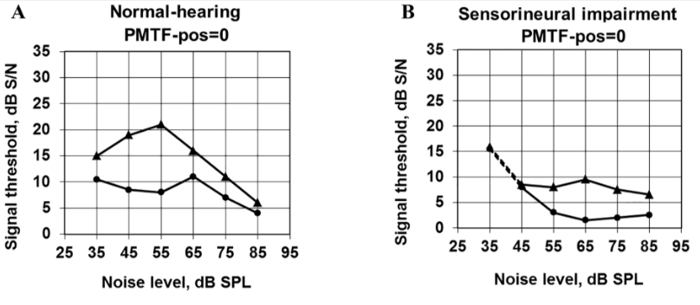

**Fig 1. Normal Hearing vs Hearing Impaired**

*2.2.2 Challenges Faced in Operating System Usage*

There are a number of difficulties that arise when using computer and mobile operating systems for people with hearing impairments.   
   
*Hearing audio cues is difficult*: Alerts, notifications, and sound effects could go completely unnoticed, causing one to become unaware of system messages or actions (Bijjarapu et al., 2023).  
  
*Comprehending spoken audio*: The user experience may be hampered by issues with voice chat, listening to multimedia content, or following audio instructions.   
  
*Distinguishing between sounds in noisy environments*: Background noise can greatly obscure system and speech sounds, making it difficult to comprehend information.

*2.2.3 Assistive Technologies and Solutions*

Fortunately, there are a number of assistive technologies that enable people who are hard of hearing to use operating systems efficiently.   
   
*Devices for amplification*:

*Hearing aids*: For those with mild to severe hearing loss, these are in-the-ear electronic devices that amplify sound (Grimm et al., 2009).

*Cochlear implants*: For those with severe hearing loss, these are surgically implanted electronic devices that stimulate the auditory nerve directly, avoiding damaged inner ear hair cells.

*Subtitles and captioning*: The use of text representations of spoken audio material that are shown on the screen to let users follow discussions, classes, or multimedia content.

*Visual alerts*: Instead of merely using audio cues to notify users of system messages, calls, or notifications, use flashing lights, screen notifications, or vibration alerts.

*Real Time Captioning*: Software that instantly translates speech to text for talks, meetings, or lectures is known as real-time captioning (RTC). As a result, users who are hard of hearing can follow the conversation and take an active part (Farhan et al., 2022) (Talaván et al., 2022).

*Tactile Feedback*: This uses vibrations or physical movements on the device surface to provide feedback. Alerts and notifications can be conveyed through distinct vibration patterns on different parts of the phone (e.g., sides, back) corresponding to specific alerts (calls, messages, etc.) (Paisa et al., 2023).

*Haptic Feedback:* This builds upon tactile feedback by providing more complex and nuanced sensations. Haptic technology can simulate textures, movements, and even create virtual objects users can feel. Phone calls can have haptic feedback that varies based on the caller's voice pitch or emotion (Paisa et al., 2023).

*Vibrotactile Feedback*: This utilizes focused vibrations to create specific tactile experiences. Alarm clocks can use strong, pulsating vibrations on the back of the phone to wake the user. Music or media playback can be translated into vibrations that vary in intensity and location based on the audio (e.g., stronger vibrations for bass, left-side vibrations for sounds panned left) (Paisa et al., 2023).

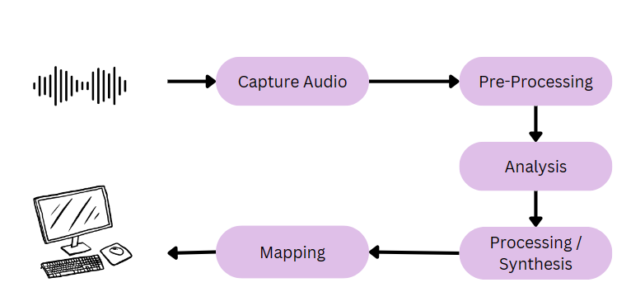

**Fig 2. Vibrotactile Technology for Auditory Impairments**

**2.3 Motor Impairments**

A variety of conditions can impair a person's ability to control their movements, which is known as a motor impairment. The types and severity of motor impairments, operating system difficulties, and assistive technologies that increase digital accessibility for people with these limitations are all covered in this section.

*2.3.1 Types and Severity of Motor Impairments*

Various types of motor impairments can affect muscle control, coordination, and movement. Here are a few typical examples:

*Cerebral Palsy*: A collection of developmental disorders that impact posture, muscle tone, and movement is known as cerebral palsy (CP). The severity of CP varies widely; some people only have mild tremors, while others have severe difficulties moving around and maintaining their balance (Haberfehlner et al., 2020).

*Spinal cord injuries*: Damage to the spinal cord that prevents the brain and body from communicating with one another. The location and severity of the damage determine how severe a SCI is; it can cause varying degrees of paralysis or weakness (Inanici et al., 2021).

*Muscular Dystrophy*: A category of hereditary illnesses known as muscular dystrophy (MD) results in progressive muscle weakness. Different muscle groups are affected by different types of MD, which also progress at different rates (da Silva et al., 2020).

*Tremor*: An involuntary shaking of a body part, usually involving the hands, head, or voice. Many neurological disorders or drug side effects can result in tremors (Huys et al., 2021).

*2.3.2 Challenges Faced in Operating System Usage*

There are various obstacles that people with motor impairments encounter when using standard computer interfaces.

*Having trouble using a traditional mouse or keyboard*: People with poor flexibility or hand-eye coordination may find it difficult to make the precise movements needed to operate a mouse or keyboard (Andreas et al., 2022).

*Reaching every area of the keyboard or screen*: Working with parts on the sides of the keyboard or screen can be challenging if you have limited range of motion (Trager et al., 2020).

*Fatigue and pain*: For people with specific motor impairments, extended use of a mouse and keyboard may result in pain or fatigue (Jacquet et al., 2021).

*2.3.3 Assistive Technologies and Solutions*

Fortunately, a range of assistive technologies enable people with motor impairments to efficiently navigate operating systems.

Alternative input devices:

*Trackballs*: Trackballs are stationary pointers with a rolling ball that allows the user to move the pointer (Pérez et al., 2020).  
  
Joysticks: Levers that move the cursor on the screen are called joysticks.   
*Head Pointers*: Devices worn on the head that follow head movements to move the cursor are called head pointers (Cicek et al., 2020).

*Touchscreen*: Fingertip or stylus interaction is possible with touchscreens, which are touch-sensitive displays.

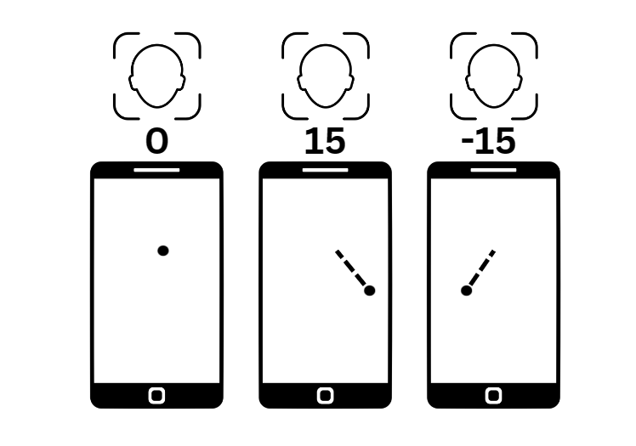

**Fig 3. Head Pointer Technology**

Onscreen keyboards: These are virtual keyboards that are displayed on a screen, making it easier for users to type using a touch screen or pointing device (Pérez et al., 2020).

*Voice control software*: This eliminates the need for a keyboard and mouse completely by allowing users to operate computers with voice commands.

*Keyboard shortcuts and macros*: Using a combination of actions, keyboard shortcuts provide rapid access to frequently used features. Multiple clicks can be eliminated by automating repetitive tasks with macros.

*Adaptive keyboards*: Adaptive keyboards are specialized keyboards with larger keys, more ergonomic layouts, or different key placements for easier use (Trager et al., 2020).

**Table 3. Assistive Technologies for Motor Impairment**

|  |  |  |
| --- | --- | --- |
| **Assistive Technology** | **Description** | **Benefit** |
| Trackball | A stationary pointing device rolled with the finger or thumb. | Easier to use than a traditional mouse for users with limited hand mobility. |
| Head pointer | Tracks head movements to control the mouse cursor on the screen. | Enables hands-free computer control for users with severe motor impairments. |
| On-screen Keyboard | Virtual keyboard displayed on the screen, allowing typing with touch or a pointing device. | Provides an alternative for users who cannot use a traditional keyboard. |

**3. ACCESSIBILITY FEATURES IN OPERATING SYSTEMS**

**3.1 Overview of Accessibility Features in Major Operating Systems (e.g., Windows, MacOS, Linux)**

A number of accessibility features have been added by software manufacturers to their systems in accordance with the revised Rehabilitation Act (Yi et al., 2015). We delineate computer accessibility(A11y) functionalities as novel input/output subsystems that provide substitute means of system interaction for individuals with disabilities. For instance, text-to-speech programs like TalkBack on Android, VoiceOver on OS X, and Narrator on Microsoft Windows offer an output subsystem that speaks to the user on behalf of visually impaired people (Jang et al., 2014).

Accessibility features such as captioning services convert the audio output of the system into visual output for users who are hard of hearing. In a similar vein, some systems can flash the screen to notify the user that audio output is there. Traditional mouse/keyboard-based input devices are being replaced with voice-based solutions for individuals with motor limitations (Rose et al., 2007).

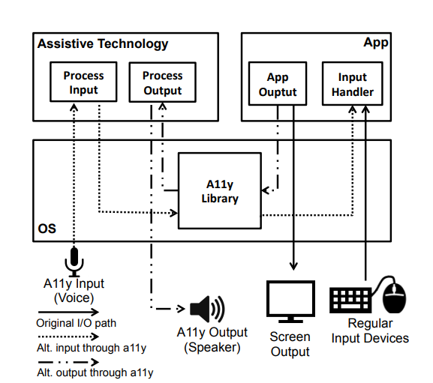

**Fig 4. How these accessibility features are generally implemented inside an OS architecture.**

**3.2 Evaluation of Current Accessibility Features**

*Text-to-Speech (TTS) Integration:* TTS systems integrated with object recognition and scene analysis modules utilize natural language processing to generate coherent and contextually appropriate audio descriptions. Research focuses on linguistic models prioritizing clarity and brevity in auditory descriptions for easy user comprehension (Safiya et al., 2023).

*Real-time Sign Language Translation:* Systems capture spoken language through speech recognition, converting it into synchronized sign language gestures displayed in videos, enhancing accessibility for users with hearing impairments (Anjimoon et al., 2024).

*Voice Control Modality:* Voice control features provided by major mobile operating systems like Android and iOS have become ubiquitous and widely accessible. Voice commands and dictation provide convenient alternatives to physical interactions, particularly beneficial in situations with limited visual attention or hand availability (Alajarmeh et al., 2021).

*Object Recognition and Scene Analysis:* Using CNNs, systems identify and categorize visual elements within images and videos, crucial for generating accurate descriptive annotations for the visually impaired. Systems interpret the context of visual scenes, understanding relationships and interactions between objects, human figures, and settings to generate comprehensive audio descriptions (Joshi et al., 2020).

*Voice User Interfaces (VUIs):* VUIs offer improved accessibility for users with limited hand dexterity, providing efficient control over devices through voice interactions. Researchers have developed innovative applications like JustSpeak, offering complete voice control over mobile devices and enhancing accessibility for users with disabilities (Corbett et al., 2016).

**3.3 Effectiveness and Limitations of Existing Features**

**Table 4. Evaluation of Existing Features**

|  |  |  |
| --- | --- | --- |
| **Assistive Technology** | **Effectiveness** | **Limitations** |
| Screen Magnifiers | Enlarges screen content for easier reading.  Compatible with various applications. | Limited usefulness for severe visual impairments. Complex content (tables, graphics) may not translate well (Zhao et al., 2009). |
| Screen Readers | Provides non – visual interaction for users with severe visual impairments. Flexible output options (sound cards, synthesizers). | Difficulty interpreting complex content (graphs, images, videos).  Web navigation challenges (complex interfaces, tables, forms) (Lazar et al., 2007).  . |
| Voice user Interfaces (VUIs) | Accessible control for users with limited dexterity or situational impairments. Convenient for mobile contexts (multitasking, limited hands). | Not always efficient as primary modality (physical interaction may be faster). Challenges in noisy environments.  Limited for graphical tasks (drawing, detailed manipulations) (Metatla et al., 2019). |
| Adaptive Image and Video Processing Techniques | Tailored sensory input based on user   needs. Dynamic adaptivity for flexible user experience. Object recognition for audio description generation. Semantic scene analysis for context understanding. | Complexity of visual data (abstract content).  Training and algorithmic bias can impact accuracy. Real-time processing challenges for interactive environments (Hong et al., 2010). |
| Braille Displays | Accurate text representation in Braille format.  Beneficial for proofreading and review tasks. | Limited graphical interface support.  Low user adoption is due to limited Braille usage (Chiang et al., 2005). |

**4. RESEARCH STUDIES ON USABILITY FOR USERS WITH DISABILITIES**

**4.1 Methodologies Used in Studying Accessibility**

**Table 5. Methodologies used in studying accessibility (Nganji et al., 2011)**

|  |  |  |  |
| --- | --- | --- | --- |
| **Stage** | **Description** | **Method** | **Output** |
| Define Scope | Specify target disability and OS functionalities to be evaluated. | Define research goals by identifying specific accessibility and usability aspects to assess. | Focused research plan. |
| Data Collection | Gather information on user experience and accessibility barriers through interviews, usability testing, surveys, and observational methods. | Observe user interaction, record actions and feedback.  Distribute surveys to collect user experience and suggestions. | Collected data including interview transcripts, usability test observations, and survey responses. |
| Data Analysis | Analyze collected data to identify accessibility issues and user needs. | Use thematic coding for interview transcripts.  Apply statistical analysis to survey responses. | Identified accessibility issues with user impact,  user needs and priorities. |
| Expert Review | Engage accessibility experts to provide detailed assessments and recommendations. | Collaborate with experts to review OS accessibility features.  Obtain expert feedback on usability test results. | Expert recommendations for OS improvements. |
| Iterative Testing | Implement iterative testing based on initial findings and expert recommendations. | Test revised OS features or updates with participants.  Gather feedback on improvements and usability. | Iterative testing report with validation of enhancements. |
| Reporting & Recommendations | Compile findings into a comprehensive report with actionable recommendations. | Document research outcomes, insights, and proposed enhancements. | Comprehensive report with actionable recommendations for OS improvement. |

**4.2 Findings from Studies on Visual Impairment-Affected Users**

Visual impairment refers to reduced vision or vision loss that cannot be corrected or improved by glasses, medicine or surgery and makes everyday tasks difficult. According to the World Health Organization (WHO), there are approximately 285 million visually impaired individuals around the world, majority of which live in developing countries. It also stated by the WHO that visual impairment is categorized in three main types; blindness, low vision and color blindness (Khaliq et al., 2019).

Auditory substitution in the paper (Ribeiro et al., 2012) refers to replacing visual elements with auditory or haptic output to improve game accessibility for the visually impaired.

One approach discussed is audio description, where verbal commentary conveys visual elements and information, allowing users to hear on-screen text read aloud (Ribeiro et al., 2012).

Another approach mentioned is the use of sound compass, which provides spatial sound cues to help visually impaired users navigate through the game environment (Khaliq et al., 2019).

Microsoft computers have a system called "Jaws" and the Apple Mac operating system has a built-in software called "Voice Over" for improving accessibility for visually impaired users. These features are mostly used in fighting games for navigation through menus and character selection (Khaliq et al., 2019).

The study highlights the profound impact of Braille on academic performance among students with visual impairment. Proficiency in Braille correlates with higher English language scores compared to non-Braille users, underscoring its academic benefits. Availability of Braille materials is crucial for educational success, emphasizing the need for widespread access to these resources (Spungin, 1996). Professional Braille instruction for educators is deemed essential to optimize student learning outcomes. Adequate Braille facilities within schools are necessary to support visually impaired students, ensuring they have the tools needed for academic development (Khaliq et al., 2019).

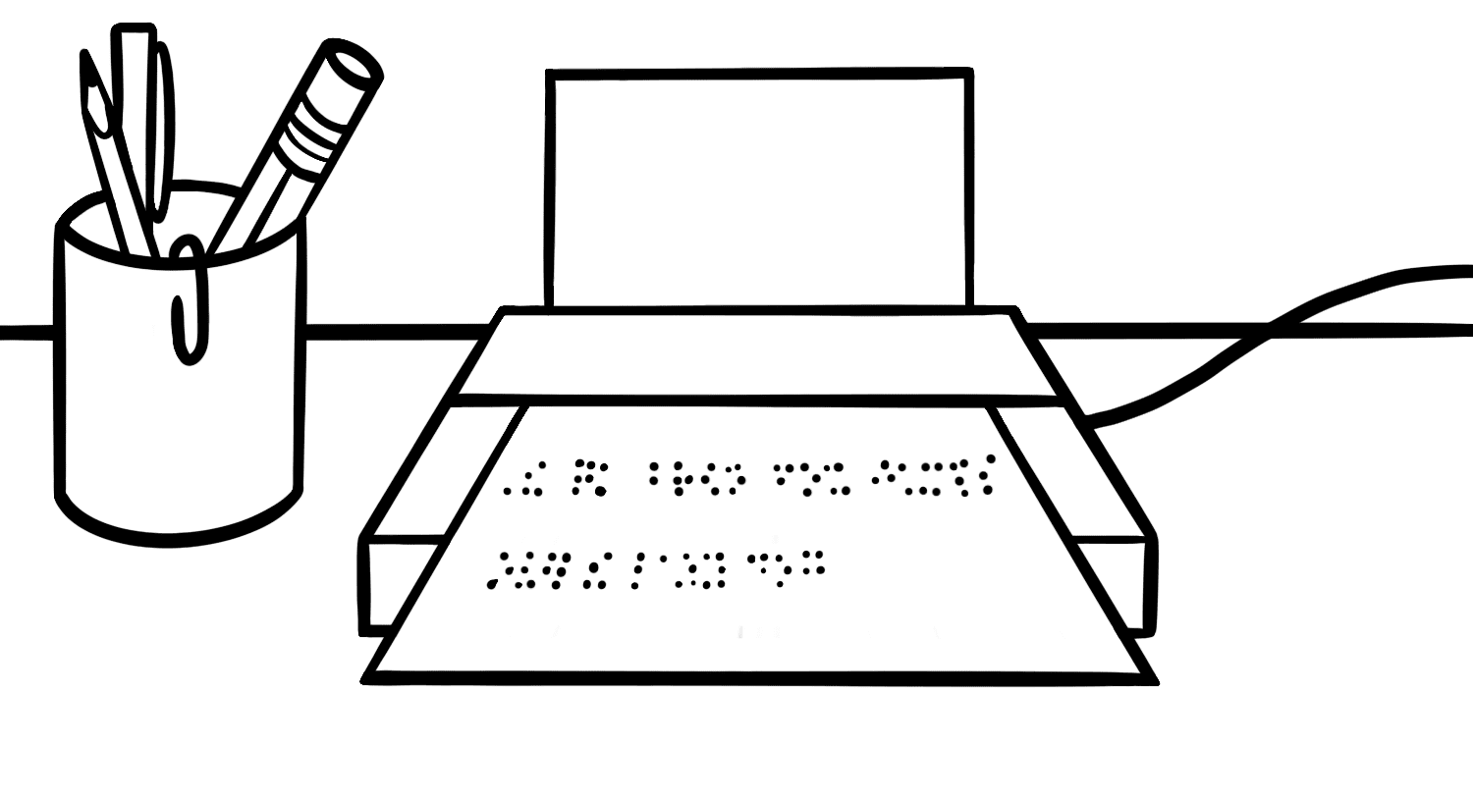

**Fig 5. Braille Embossers in computers.**

Technological aids like Computer Braille Embossers are recognized for their potential to enhance Braille literacy, despite cost considerations. Overall, the research underscores Braille's significance in fostering academic achievements and highlights the importance of comprehensive support systems, including materials, training, and facilities, for students with visual impairment (Odoh et al., 2016).

**4.3 Findings from Studies on Auditory Impairment-Affected Users**

Operating systems has advanced text-to-speech technologies to facilitate real-time conversion of text into spoken language. This feature enables users with hearing impairments to engage more effectively with auditory content, such as spoken instructions or alerts (Gersten et al., 1998).

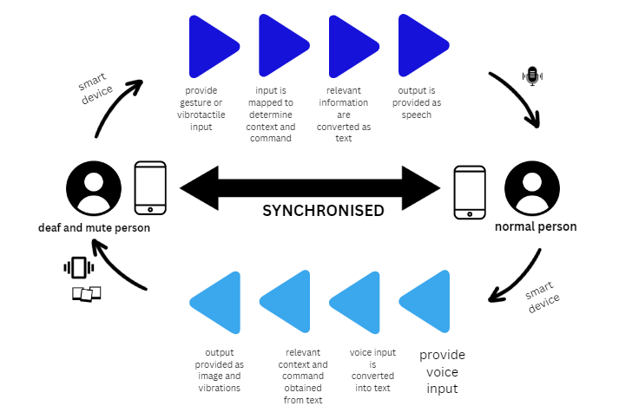

**Fig 6. Communication between deaf & mute and normal person**

Operating systems provides robust support for web-based and mobile applications specifically designed for individuals with hearing impairments. This includes seamless integration of communication apps that utilize visual cues or text-based interactions to enhance accessibility and foster effective communication (Haksiz, 2014).

Operating systems prioritizes compatibility with visual education tools, such as multimedia content accessible via the internet, television, or digital storage media. By ensuring smooth integration and playback of visual content, operating systems significantly enhances educational experiences for users with auditory impairments (Baglama et al., 2018).

Operating systems designed for tablets and touchscreen devices incorporates accessibility features tailored to users with auditory impairments. This includes customizable visual feedback, gesture-based controls, and compatibility with educational applications that focus on visual learning and skill development (Haksiz, 2014).

**4.4** **Findings from Studies on Motor Impairment-Affected Users**

*4.4.1 Eye tracking technology*

Eye tracking technology revolutionizes computer interaction for individuals with motor impairments by leveraging infrared light and cameras to monitor eye movements (Tai et al., 2008). This system analyzes eye position and gaze direction to determine where the user is looking on the screen. In operating systems supporting eye tracking, users control the mouse cursor by directing their gaze towards different screen areas. By fixating on a specific point, the cursor moves accordingly, offering precise control over graphical interfaces. This method enables users to perform various actions like clicking, dragging, scrolling, and selecting using eye movements. For instance, prolonged fixation on an element simulates a mouse click, while rapid eye movements can trigger scrolling or other gestures (Pasqualotto et al., 2015).

A key benefit of eye tracking is hands-free input, making it invaluable for individuals with severe motor impairments who cannot use conventional mouse or keyboard inputs. Eye tracking technology extends beyond computer accessibility, finding applications in assistive technology, research, and gaming. It empowers users to communicate, control devices, and interact with digital content independently. Eye tracking enhances inclusion by providing an intuitive interface that complements diverse abilities. Eye tracking continues to evolve, driven by advancements in sensor technologies and machine learning algorithms, promising even greater accessibility and functionality for users with motor impairments across various domains (Tai et al., 2008).

*4.4.2 Head tracking system*

Head tracking systems offer individuals with limited hand or arm mobility a means to control mouse cursors and interact with on-screen elements using head movements (Manresa-Yee at el., 2016). These systems utilize specialized cameras or sensors to monitor head orientation, translating these movements into cursor actions on the screen. As the user moves their head, the cursor responds accordingly, enabling precise control over cursor direction and speed through tilting or turning movements (Rodrigues et al., 2017).

Users can execute mouse actions such as clicking, double-clicking, and dragging by combining head movements with specific gestures or commands. For instance, nodding the head or employing predefined head gestures can simulate mouse clicks, facilitating hands-free operation of computers and assistive devices (Manresa-Yee at el., 2016).

Like eye tracking, head tracking provides a hands-free input method, enabling users to interact with computers or assistive devices without relying on manual inputs. Head tracking technology is used in assistive technologies, virtual reality (VR) and augmented reality (AR) applications, and gaming. It enables individuals with motor impairments to access and navigate digital content more effectively (Wang et al., 2018).

*4.4.3 Gesture recognition technologies*

Gesture recognition technologies offer innovative solutions for individuals with motor impairments, allowing them to interact with operating systems and digital interfaces through intuitive gestures instead of traditional input devices. Advanced gesture controls involve sophisticated algorithms that analyze subtle movements captured by cameras or sensors. These algorithms detect and interpret gestures, enabling users to perform actions like clicking, scrolling, and navigating without physical contact with keyboards or mouse (Morrison et al., 2002).

Key aspects of advanced gesture controls include precise gesture detection, accurate interpretation of gestures into system actions, customization options for personalized interaction methods, and improved accessibility for individuals with varying levels of motor impairment (Morrison et al., 2002). By harnessing the power of machine learning, gesture recognition systems can adapt and improve over time. Machine learning models are trained using extensive datasets of gesture inputs, learning patterns and associations between gestures and corresponding actions. This adaptation allows systems to recognize personalized gestures and adjust to individual users' abilities and preferences (Nogales et al., 2021).

Machine learning also enables contextual understanding of gestures, considering factors like user behavior, environmental conditions, and specific application requirements (Siddiqui et al., 2021). Real-time feedback provided by machine learning algorithms enhances the accuracy and responsiveness of gesture recognition systems, optimizing performance for users with diverse motor impairments. Continuous learning techniques ensure that gesture interpretation models evolve and improve, driving advancements in accessibility and inclusivity across computing platforms (Nogales et al., 2021).

**5. SOCIAL AND POLICY IMPLICATIONS**

The integration of digital technologies in public, social, and economic realms necessitates a strong emphasis on accessibility, usability, and equity in their implementation. As technology rapidly evolves, there is a risk of widening the digital divide if user adaptations and device usability lag behind. This divide can particularly affect the participation of individuals with disabilities, who make up a significant global population exceeding one billion (Bricout et al., 2021).

Addressing accessibility and disability features becomes even more critical during crises such as the COVID-19 pandemic, where communication, service provision, and healthcare barriers must be mitigated (Gleason et al., 2020).

The study underscores the persistent inequities in Internet access and online social networking among young people with disabilities. Policymakers must prioritize initiatives that bridge this digital divide, ensuring equitable access to digital resources and technologies for all, regardless of disability status or socioeconomic background (Newman et al., 2017).

The concept of "smart equality" rooted in disability insights and digital inclusion has significant social and policy implications, especially in contexts like Singapore that prioritize technological advancements and social experimentation (Goggin et al., 2022).

**6. CASE STUDIES AND BEST PRACTICES**

This section explores the topic of operating system accessibility, highlighting best practices and revealing successful strategies to improve user experience. We can draw important insights and best practices from real-world case studies to guide future advancements in this important area.

*Apple's VoiceOver:* Apple's VoiceOver on macOS is an excellent illustration of accessibility. Users who are blind or visually impaired can easily navigate the operating system thanks to the built-in screen reader. VoiceOver ensures a seamless and educational experience by utilizing trackpad gestures and keyboard commands to give users an in-depth explanation of on-screen elements and interface components (Sayago et al., 2020).

*Microsoft's Ease of Access:* With its "Ease of Access" suite, Microsoft Windows offers a comprehensive approach to accessibility. Users are given the tools they need with features like Magnifier, a screen magnification tool, and Narrator, a powerful screen reader. Windows also supports a variety of input methods, such as speech recognition and on-screen keyboards, providing flexibility for users with different needs (Chandel et al., 2023).

**CONCLUSION**

To conclude, research on the usability of technology for people with disabilities highlights the critical role that inclusive design and technological improvements play in improving accessibility (Nganji et al. 2011) have emphasized methodologies that emphasize comprehensive research procedures, such as goal setting, expert consultations, user experience assessments, iterative testing, and useful recommendations for operating system enhancements.

An assessment of existing accessibility features highlights the need for continued innovation and inclusive design approaches by highlighting both their benefits and drawbacks. Even with ongoing complexity, developments in AI-powered solutions and cooperative initiatives present encouraging avenues for standardizing accessibility, enabling disabled people, and promoting diversity in digital spaces. To create fully inclusive digital landscapes, stakeholders must continue to collaborate and adhere to accessibility requirements.

Despite advancements, addressing accessibility challenges requires a holistic and collaborative approach, acknowledging barriers like the digital divide and rapid technological evolution. Solutions like vibro-audio interfaces and improved captioning demonstrate progress, while future efforts should prioritize refining screen reader technologies, gesture-based interfaces, leveraging AI for personalized accessibility, and integrating intelligent personal assistants.

**REFERENCES**

Alajarmeh, N. (2021). Non-visual access to mobile devices: A survey of touchscreen accessibility for users who are visually impaired. Displays, 70, 102081.

Andreas, D., Six, H., Bliek, A., & Beckerle, P. (2022, October). Personalizable Alternative Mouse and Keyboard Interface for People with Motor Disabilities of Neuromuscular Origin. In Proceedings of the 24th International ACM SIGACCESS Conference on Computers and Accessibility (pp. 1-4).

Anjimoon, S., Swathi, B., Sobti, R., Kumar, A., Chauhan, S., Abdul-jabbar, A. A., & Bandhu, D. (2024). A Review on Enhancing Accessibility Through Image and Video Processing: Solutions for Differently Abled Individuals. In E3S Web of Conferences (Vol. 505, p. 03007). EDP Sciences.

Baglama, B., Haksiz, M., & Uzunboylu, H. (2018). Technologies used in education of hearing impaired individuals. *International Journal of Emerging Technologies in Learning (Online)*, *13*(9), 53.

Baker, P., Bricout, J. C., Moon, N. W., Coughlan, B., & Pater, J. (2013). Communities of participation: A comparison of disability and aging identified groups on Facebook and LinkedIn. Telematics and Informatics, 30(1), 22–34.

Bijjarapu, P. K., Saini, N. K., Arra, S. Y., Nune, S. K., Bheemagari, D., & Babu, G. C. (2023, November). Color Depiction and Push Notification System for Daily Sounds. In 2023 International Conference on Advances in Computation, Communication and Information Technology (ICAICCIT) (pp. 996-1000). IEEE.

Bilal Salih, H. E., Takeda, K., Kobayashi, H., Kakizawa, T., Kawamoto, M., & Zempo, K. (2022). Use of auditory cues and other strategies as sources of spatial information for people with visual impairment when navigating unfamiliar environments. International Journal of Environmental Research and Public Health, 19(6), 3151.

Borg, J., Lantz, A., & Gulliksen, J. (2015). Accessibility to electronic communication for people with cognitive disabilities: a systematic search and review of empirical evidence. Universal Access in the Information Society, 14(4), 547-562.

Bricout, J., Baker, P. M., Moon, N. W., & Sharma, B. (2021). Exploring the smart future of participation: Community, inclusivity, and people with disabilities. International Journal of E-Planning Research (IJEPR), 10(2), 94-108.

Burgstahler, S., Jirikowic, T., Kolko, B., & Eliot, M. (2004). Software Accessibility, usability testing and individuals with disabilities. Information Technology and Disabilities, 10(2).

Chandel, M., & Sood, M. (2023). Accessibility of Software/Hardware. Computer Assistive Technologies for Physically and Cognitively Challenged Users, 26.

Chiang, M. F., Cole, R. G., Gupta, S., Kaiser, G. E., & Starren, J. B. (2005). Computer and world wide web accessibility by visually disabled patients: Problems and solutions. Survey of ophthalmology, 50(4), 394-405.

Choi, W. Y., & Rajkumar, T. M. (1996). Computing for the Disabled. Journal of Computer Information Systems, 36(4), 77-85.

Cicek, M., Dave, A., Feng, W., Huang, M. X., Haines, J. K., & Nichols, J. (2020, October). Designing and evaluating head-based pointing on smartphones for people with motor impairments. In Proceedings of the 22nd International ACM SIGACCESS Conference on Computers and Accessibility (pp. 1-12).

Corbett, E., & Weber, A. (2016, September). What can I say? addressing user experience challenges of a mobile voice user interface for accessibility. In Proceedings of the 18th international conference on human-computer interaction with mobile devices and services (pp. 72-82).

da Silva, T. D., Ribeiro-Papa, D. C., Coe, S., Malheiros, S. R. P., Massetti, T., Junior, C. D. M. M., ... & Dawes, H. (2020). Evaluation of speed-accuracy trade-off in a computer task to identify motor difficulties in individuals with Duchenne Muscular Dystrophy-a cross-sectional study. Research in developmental disabilities, 96, 103541.

Ellcessor, E. (2015). Blurred lines: Accessibility, disability, and definitional limitations. First Monday.

Farhan, W., & Razmak, J. (2022). A comparative study of an assistive e-learning interface among students with and without visual and hearing impairments. Disability and Rehabilitation: Assistive Technology, 17(4), 431-441.

Ferri, D., & Favalli, S. (2018). Web accessibility for people with disabilities in the European Union: Paving the road to social inclusion. Societies, 8(2), 40.

Gersten, R. & Baker, S. (1998). Real world use of scientific concepts: Integrating situated cognition with explicit instruction. Exceptional Children, 65(1), 23-25.

Gleason, C., Valencia, S., Kirabo, L., Wu, J., Guo, A., Jeanne Carter, E., ... & Pavel, A. (2020, October). Disability and the COVID-19 pandemic: Using Twitter to understand accessibility during rapid societal transition. In Proceedings of the 22nd International ACM SIGACCESS Conference on Computers and Accessibility (pp. 1-14).

Goggin, G., & Zhuang, K. V. (2022). Disability as smart equality: Inclusive technology in a digitally advanced nation. In Vulnerable People and Digital Inclusion: Theoretical and Applied Perspectives (pp. 257-275). Cham: Springer International Publishing.

Gregor, P., Sloan, D., & Newell, A. F. (2005). Disability and technology: building barriers or creating opportunities?. Advances in computers, 64, 283-346.

Grimm, G., Guilmin, G., Poppen, F., Vlaming, M. S., & Hohmann, V. (2009). The personal hearing system—A software hearing aid for a personal communication system. EURASIP Journal on Advances in Signal Processing, 2009, 1-9.

Guymer, R., & Wu, Z. (2020). Age‐related macular degeneration (AMD): more than meets the eye. The role of multimodal imaging in today's management of AMD—a review. Clinical & Experimental Ophthalmology, 48(7), 983-995.

Haberfehlner, H., Goudriaan, M., Bonouvrié, L. A., Jansma, E. P., Harlaar, J., Vermeulen, R. J., ... & Buizer, A. I. (2020). Instrumented assessment of motor function in dyskinetic cerebral palsy: a systematic review. Journal of neuroengineering and rehabilitation, 17, 1-12.

Haksiz, M. (2014). Investigation of tablet computer use in special education teachers’ courses. Procedia-Social and Behavioral Sciences, 141, 1392-1399.

Hauck, N., & Mahdavi, A. (2022). An Investigation of the Implications of Visual Impairment for Illumination Requirements. Journal of Visual Impairment & Blindness, 116(2), 216-229.

Hong, R., Wang, M., Xu, M., Yan, S., & Chua, T. S. (2010, October). Dynamic captioning: video accessibility enhancement for hearing impairment. In Proceedings of the 18th ACM international conference on Multimedia (pp. 421-430).

Hussain, J., Ul Hassan, A., Muhammad Bilal, H. S., Ali, R., Afzal, M., Hussain, S., ... & Lee, S. (2018). Model-based adaptive user interface based on context and user experience evaluation. Journal on Multimodal User Interfaces, 12, 1-16.

Huys, A. C. M., Haggard, P., Bhatia, K. P., & Edwards, M. J. (2021). Misdirected attentional focus in functional tremor. Brain, 144(11), 3436-3450.

Inanici, F., Brighton, L. N., Samejima, S., Hofstetter, C. P., & Moritz, C. T. (2021). Transcutaneous spinal cord stimulation restores hand and arm function after spinal cord injury. IEEE Transactions on Neural Systems and Rehabilitation Engineering, 29, 310-319.

Jacquet, T., Poulin-Charronnat, B., Bard, P., & Lepers, R. (2021). Persistence of mental fatigue on motor control. Frontiers in Psychology, 11, 588253.

Jang, Y., Song, C., Chung, S. P., Wang, T., & Lee, W. (2014, November). A11y attacks: Exploiting accessibility in operating systems. In Proceedings of the 2014 ACM SIGSAC Conference on Computer and Communications Security (pp. 103-115).

Joshi, R. C., Yadav, S., Dutta, M. K., & Travieso-Gonzalez, C. M. (2020). Efficient multi-object detection and smart navigation using artificial intelligence for visually impaired people. Entropy, 22(9), 941.

Khaliq, I., & Torre, I. D. (2019, September). A study on accessibility in games for the visually impaired. In *Proceedings of the 5th eai international conference on smart objects and technologies for social good* (pp. 142-148).

Lazar, J., Allen, A., Kleinman, J., & Malarkey, C. (2007). What frustrates screen reader users on the web: A study of 100 blind users. International Journal of human-computer interaction, 22(3), 247-269.

Lazzaro, J. J. (1995). Computers for the Disabled. In Readings in Human–Computer Interaction (pp. 724-727). Morgan Kaufmann.

Lindblad, A. C., Rosenhall, U., Olofsson, Å., & Hagerman, B. (2014). Tinnitus and other auditory problems–Occupational noise exposure below risk limits may cause inner ear dysfunction. PloS one, 9(5), e97377.

Malone, L. A., Mendonca, C. J., Mohanraj, S., Misko, S. R., Moore, J., Brascome, J. M., & Thirumalai, M. (2023). Usability of the GAIMplank video game controller for people with mobility impairments: observational study. JMIR Serious Games, 11, e38484.

Manresa-Yee, C., Roig-Maimó, M. F., & Varona, J. (2016, September). Mobile accessibility: a head-tracker for users with motor disabilities. In *Proceedings of the XVII International Conference on Human Computer Interaction* (pp. 1-2).

Metatla, O., Oldfield, A., Ahmed, T., Vafeas, A., & Miglani, S. (2019, May). Voice user interfaces in schools: Co-designing for inclusion with visually-impaired and sighted pupils. In Proceedings of the 2019 CHI Conference on Human Factors in Computing Systems (pp. 1-15).

Morrison, K., & McKenna, S. J. (2002). Automatic visual recognition of gestures made by motor-impaired computer users. Technology and Disability, 14(4), 197-203.

Nair, V., Ma, S. E., Gonzalez Penuela, R. E., He, Y., Lin, K., Hayes, M., ... & Smith, B. A. (2022, October). Uncovering Visually Impaired Gamers’ Preferences for Spatial Awareness Tools Within Video Games. In Proceedings of the 24th International ACM SIGACCESS Conference on Computers and Accessibility (pp. 1-16).

Newman, L., Browne‐Yung, K., Raghavendra, P., Wood, D., & Grace, E. (2017). Applying a critical approach to investigate barriers to digital inclusion and online social networking among young people with disabilities. Information Systems Journal, 27(5), 559-588.

Nganji, J. T., & Nggada, S. H. (2011). Disability-aware software engineering for improved system accessibility and usability. International Journal of Software Engineering and Its Applications, 5(3), 47-62.

Nogales, R. E., & Benalcázar, M. E. (2021). Hand gesture recognition using machine learning and infrared information: a systematic literature review. *International Journal of Machine Learning and Cybernetics*, *12*(10), 2859-2886.

Odoh, A. O. (2016). The impacts of braille reading and writing on the academic performance of students with visual impairment in Jos Metropolis. *Unpublished doctoral thesis, University of Jos, Nigeria*.

Paisa, R., Nilsson, N. C., & Serafin, S. (2023). Tactile displays for auditory augmentation–A scoping review and reflections on music applications for hearing impaired users. Frontiers in Computer Science, 5, 1085539.

Palani, H. P. (2013). Making graphical information accessible without vision using touch-based devices.

Pasqualotto, E., Matuz, T., Federici, S., Ruf, C. A., Bartl, M., Olivetti Belardinelli, M., ... & Halder, S. (2015). Usability and workload of access technology for people with severe motor impairment: a comparison of brain-computer interfacing and eye tracking. *Neurorehabilitation and neural repair*, *29*(10), 950-957.

Pérez, J. E., Arrue, M., Valencia, X., & Abascal, J. (2020). Longitudinal study of two virtual cursors for people with motor impairments: A performance and satisfaction analysis on web navigation. IEEE Access, 8, 110381-110396.

Reddy, B. R., & Mahender, E. (2013). Speech to text conversion using android platform. International Journal of Engineering Research and Applications (IJERA), 3(1), 253-258.

Ribeiro, F., Florencio, D., Chou, P., and Zhang, Z. (2012). Auditory augmented reality: Object sonification for the visually impaired. IEEE 14th Int. Workshop Multimedia Signal Process, 319–324.

Rivas-Costa, C., Anido-Rifón, L., Fernández-Iglesias, M. J., Gómez-Carballa, M. A., Valladares-Rodríguez, S., & Soto-Barreiros, R. (2014). An accessible platform for people with disabilities. International Journal of Human-Computer Interaction, 30(6), 480-494.

Rodrigues, A. S., da Costa, V. K., Cardoso, R. C., Machado, M. B., Machado, M. B., & Tavares, T. A. (2017, June). Evaluation of a head-tracking pointing device for users with motor disabilities. In *Proceedings of the 10th International Conference on PErvasive Technologies Related to Assistive Environments* (pp. 156-162).

Rogers, M., & Rajkumar, T. M. (1999). Developing electronic commerce web sites for the visually impaired. Information Systems Management, 16, 15-25.

Rose, R. M. (2007). Research Committee Issues Brief: Access and Equity in Online Classes and Virtual Schools. North American Council for Online Learning.

Safiya, K. M., & Pandian, R. (2023). A real-time image captioning framework using computer vision to help the visually impaired. Multimedia Tools and Applications, 1-26.

Saleem, Y. (2014). Windows interface for disabled person. Pakistan Journal of Science, 66(1).

Sayago, S., & Ribera, M. (2020, December). Apple Siri (input)+ Voice Over (output)= a de facto marriage: An exploratory case study with blind people. In Proceedings of the 9th International Conference on Software Development and Technologies for Enhancing Accessibility and Fighting Info-exclusion (pp. 6-10).

Shih, C. T. S. C. H., & Luo, C. H. (2007, April). Mouse manipulation through switch-control input device for people with disabilities. In Proceedings of the 6th Conference on WSEAS International Conference on Applied Computer Science-Volume 6 (pp. 408-413).

Siddiqui, U. A., Ullah, F., Iqbal, A., Khan, A., Ullah, R., Paracha, S., ... & Kwak, K. S. (2021). Wearable-sensors-based platform for gesture recognition of autism spectrum disorder children using machine learning algorithms. *Sensors*, *21*(10), 3319.

Spungin, S.J. (1996). Braille literacy: issues for blind persons, families, professionals, and producers of Braille. NewYork: AFB.

Szopa, A. (2021). Comparison Analysis of Accessible Features Built into Operating Systems. In Advances in Industrial Design: Proceedings of the AHFE 2021 Virtual Conferences on Design for Inclusion, Affective and Pleasurable Design, Interdisciplinary Practice in Industrial Design, Kansei Engineering, and Human Factors for Apparel and Textile Engineering, July 25-29, 2021, USA (pp. 338-343). Springer International Publishing.

Tai, K., Blain, S., & Chau, T. (2008). A review of emerging access technologies for individuals with severe motor impairments. *Assistive technology*, *20*(4), 204-221.

Talaván, N., Lertola, J., & Moreno, A. I. (2022). Audio description and subtitling for the deaf and hard of hearing: Media accessibility in foreign language learning. Translation and Translanguaging in Multilingual Contexts, 8(1), 1-29.

Trager, M. H., Wilkins, K. B., Koop, M. M., & Bronte-Stewart, H. (2020). A validated measure of rigidity in Parkinson's disease using alternating finger tapping on an engineered keyboard. Parkinsonism & related disorders, 81, 161-164.

Tyler, R. S., & Baker, L. J. (1983). Difficulties experienced by tinnitus sufferers. Journal of Speech and Hearing disorders, 48(2), 150-154.

Vashist, P., Senjam, S. S., Gupta, V., Gupta, N., Shamanna, B. R., Wadhwani, M., ... & Bharadwaj, A. (2022). Blindness and visual impairment and their causes in India: Results of a nationally representative survey. PLoS One, 17(7), e0271736.

Wang, K. J., Liu, Q., Zhao, Y., Zheng, C. Y., Vhasure, S., Liu, Q., ... & Mao, Z. H. (2018, December). Intelligent wearable virtual reality (VR) gaming controller for people with motor disabilities. In *2018 IEEE International Conference on Artificial Intelligence and Virtual Reality (AIVR)* (pp. 161-164). IEEE.

Yi, Y. J. (2015). Compliance of Section 508 in public library systems with the largest percentage of underserved populations. Government information quarterly, 32(1), 75-81.

Zhao, Z., Rau, P. L. P., Zhang, T., & Salvendy, G. (2009). Visual search-based design and evaluation of screen magnifiers for older and visually impaired users. International Journal of Human-Computer Studies, 67(8), 663-675.